Week #3 Lecture Notes

Chapter #5 Linked Lists

Error in author's source code:

linkedList.h contains

friend ostream& operator<< (ostream&, const linkedListType<Type>&);

<Type> is missing. It should be

friend ostream& operator<< <Type> (ostream&, const linkedListType<Type>&);

Please make this correction before you try to use linkedList.h in your programs.

Arrays and linked lists are the basic data structures taught in computer science. While both structures can be used to store any list of items, arrays use contiguously allocated memory to store the items, whereas the linked list allocates the memory dynamically to store each item. A particular item in an array can be directly accessed using an index, whereas pointers are used to traverse the linked list. So, the code complexity is bit higher for the linked list implementation compared to the array implementation. From the usage point of view, complexity of various list operations varies between array-based lists and linked lists. So, the designer should decide to use array or linked list based on the properties of the specific problem in hand.

Binary search: The book touches upon binary search algorithm which can be used in array based lists if the items are in sorted order. While the details of binary search algorithm will be discussed in detail in Chapter 9, let us understand the basic philosophy of this powerful operation here: Take the following real-life scenario: You have a deck of 1000 cards, each card has a number on it, and the cards are in sorted order based on the number on each card (Similar to a deck of playing cards, except the first card, you have to choose a specific card to view the number on it). Now, what will be quickest way to find out whether a specific number is written on one of the cards? Let us continue this discussion in discussion forum.

Linked lists: A new term “node” is introduced for explain the linked list. Each node contains the data item and the pointer to next node, as shown below:

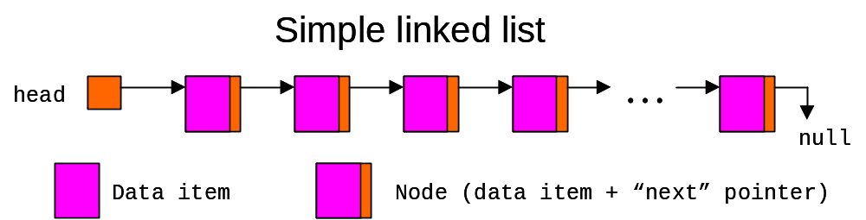

Book explains traversing linked list, item insertion & deletion, and building linked lists very well in pages 278-289. Go through these pages bit slowly to understand, particularly the handling of pointers in item insertion and deletion. You may notice that insertion and deletion of an item in linked lists is not as intuitive or simple as arrays. Given a position in the linked list, insertion can be done ONLY after that position, not at that position. Similarly, to delete a particular item from the linked list, previous position is needed. Another complexity comes from the fact that special handling is required when first or last item is inserted or deleted.

While the data items can be in any order in linked lists, they have to be in sorted order in ordered linked lists. All linked list operations except insertion can be reused as they are. While a new item can be inserted at any position in linked list, we have to search the ordered linked list, and insert it the correct position s.t. the sorted order property is not violated. Search and delete operations can be modified to improve their efficiency, taking advantage of the fact that the items in the list are ordered.

Note that “next” pointer in each node of linked list makes the linked list to consume more memory to store the same # of data items, compared to the array based list. Doubly linked list contains additional pointer “back” to point to previous node, and consumes even more memory. However, this new pointer enables the user to traverse the linked list in reverse direction. While we have to mess with more pointers when inserting or deleting a node in doubly linked list, these operations are more intuitive – Taking advantage of “back” pointer, it is possible to insert a new node at specified position, and it is also possible to delete the node at specified position.

We covered two array based STL sequence containers (“vector” and “deque”) in week #2. They were built on array based lists. Another STL sequence container “list” is built on doubly linked list structure:

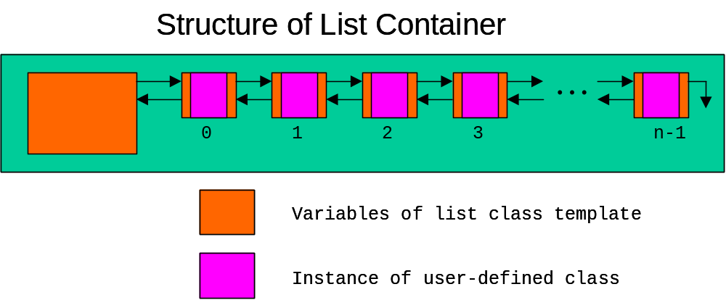

Keeping special header and trailer nodes in linked list reduce the complexity of insert and delete operations, since these operations need not consider the impact to “first” and “last” pointers in the linked list. While the concept behind circular linked lists is simple to understand (i.e. make “next” pointer of the final node point to the first node instead of “null”), it is difficult to find the obvious use for it. In fact, if search operation is not written carefully, we can end up with infinite loop ☺

